This lab session covers the usage of the Wireshark application to monitor and capture the outgoing and incoming packets from a network connection (WIFI, ethernet, etc.). Specifically, students should be able to analyze HTTP, HTTPS, TCP/IP, and UDP protocols using Wireshark, a network protocol analyzer, and draw conclusions.

**Pre-lab Preparation:**

1. Review the basics and the structure of HTTP, TCP/IP, and UDP protocols,
2. Install Wireshark and ensure it is running on your computer,
3. Create an online, *publically accessible* Git repository to host and upload your work in the labs. We recommend you use GitHub or GitLab.

**Lab Activities:**

**Part 1: Capturing HTTP Traffic.**

**Task 1: Start Wireshark and capture packets.**

Step 1: Open Wireshark.

Step 2: Select the network interface connected to the internet (e.g., Ethernet or Wi-Fi).

Step 3: Click the "Start Capturing Packets" button (the shark fin icon).

Step 4: Open your favorite web browser and navigate to (<https://qu.edu.sa>) website.

Step 5: After the website has fully loaded, stop capturing packets by clicking the red stop button in Wireshark.

**Task 2: Filter HTTP packets and analyze them.**

Step 1: In the filter bar, type http and press Enter. This filters out only the HTTP packets from the capture.

Step 2: Select any HTTP packet to view its details.

Step 3: Observe the HTTP request and response messages. Note the method (GET, POST), URL, response codes (200 OK, 404 Not Found), etc.

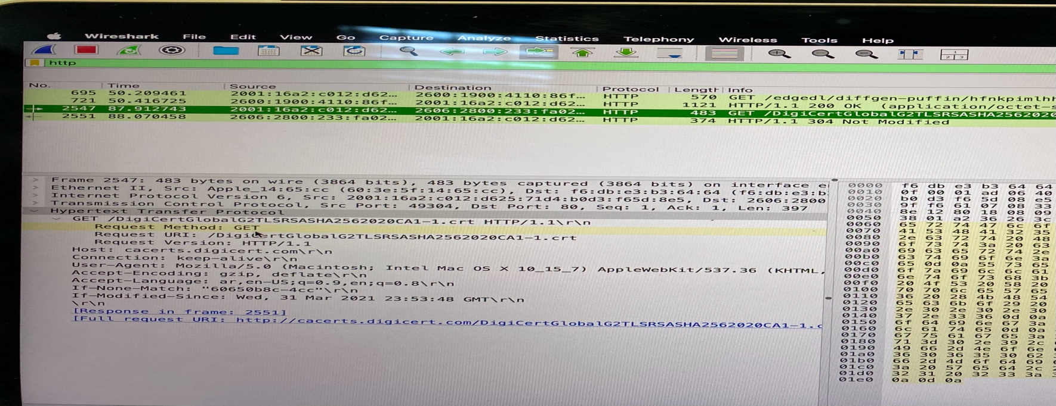

**Task 1: Filter TCP packets**

**Part 2: Analyzing TCP/IP Traffic.**

**Step 1:** Clear the previous filter and type TCP to focus on TCP packets.

**Step 2:** Select a TCP packet related to your HTTP request/response.

**Step 3:** Right-click on the packet and select "Follow" -> "TCP Stream".

**Step 4:** This shows the entire conversation between the client and server.

**Task 2: Analyze TCP handshake and investigate Data Transfer and Termination**

**Step 1:** Find and select packets related to the TCP three-way handshake:

* + SYN: Initiates a connection.
  + SYN-ACK: Acknowledges and responds to the SYN.
  + ACK: Acknowledges the SYN-ACK and establishes the connection.

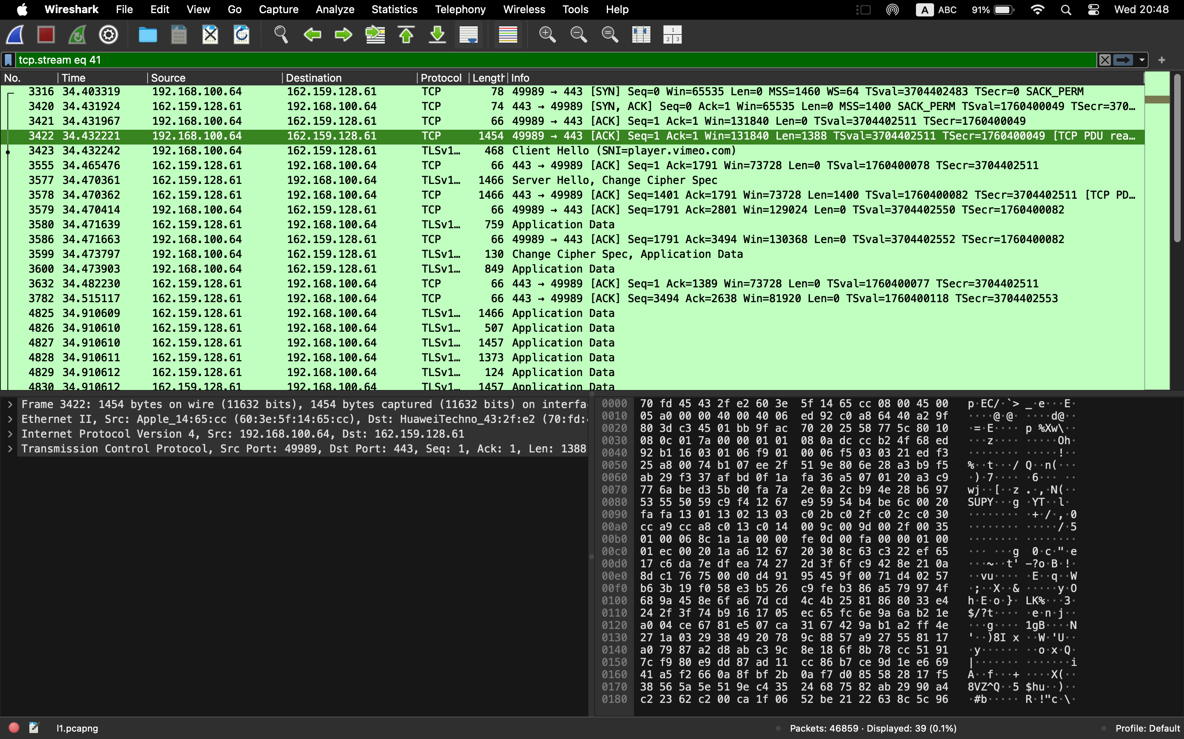

**Step 2:** Note the sequence and acknowledgment numbers. Screenshot and upload your image to your online git repository.

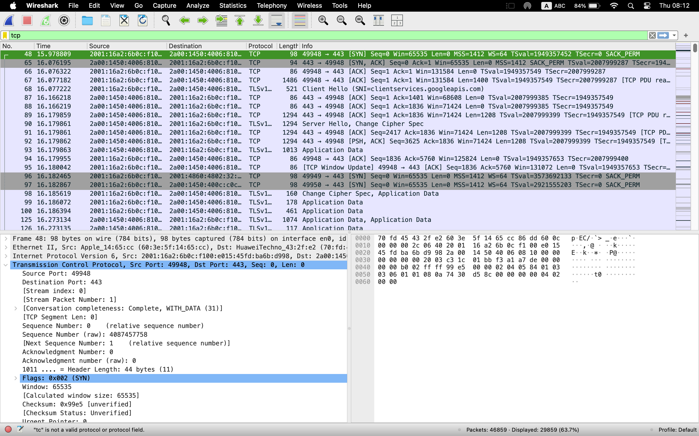

**Step 3:** Observe the data packets exchanged between the client and server. Take a screenshot and upload it to your online git repo.

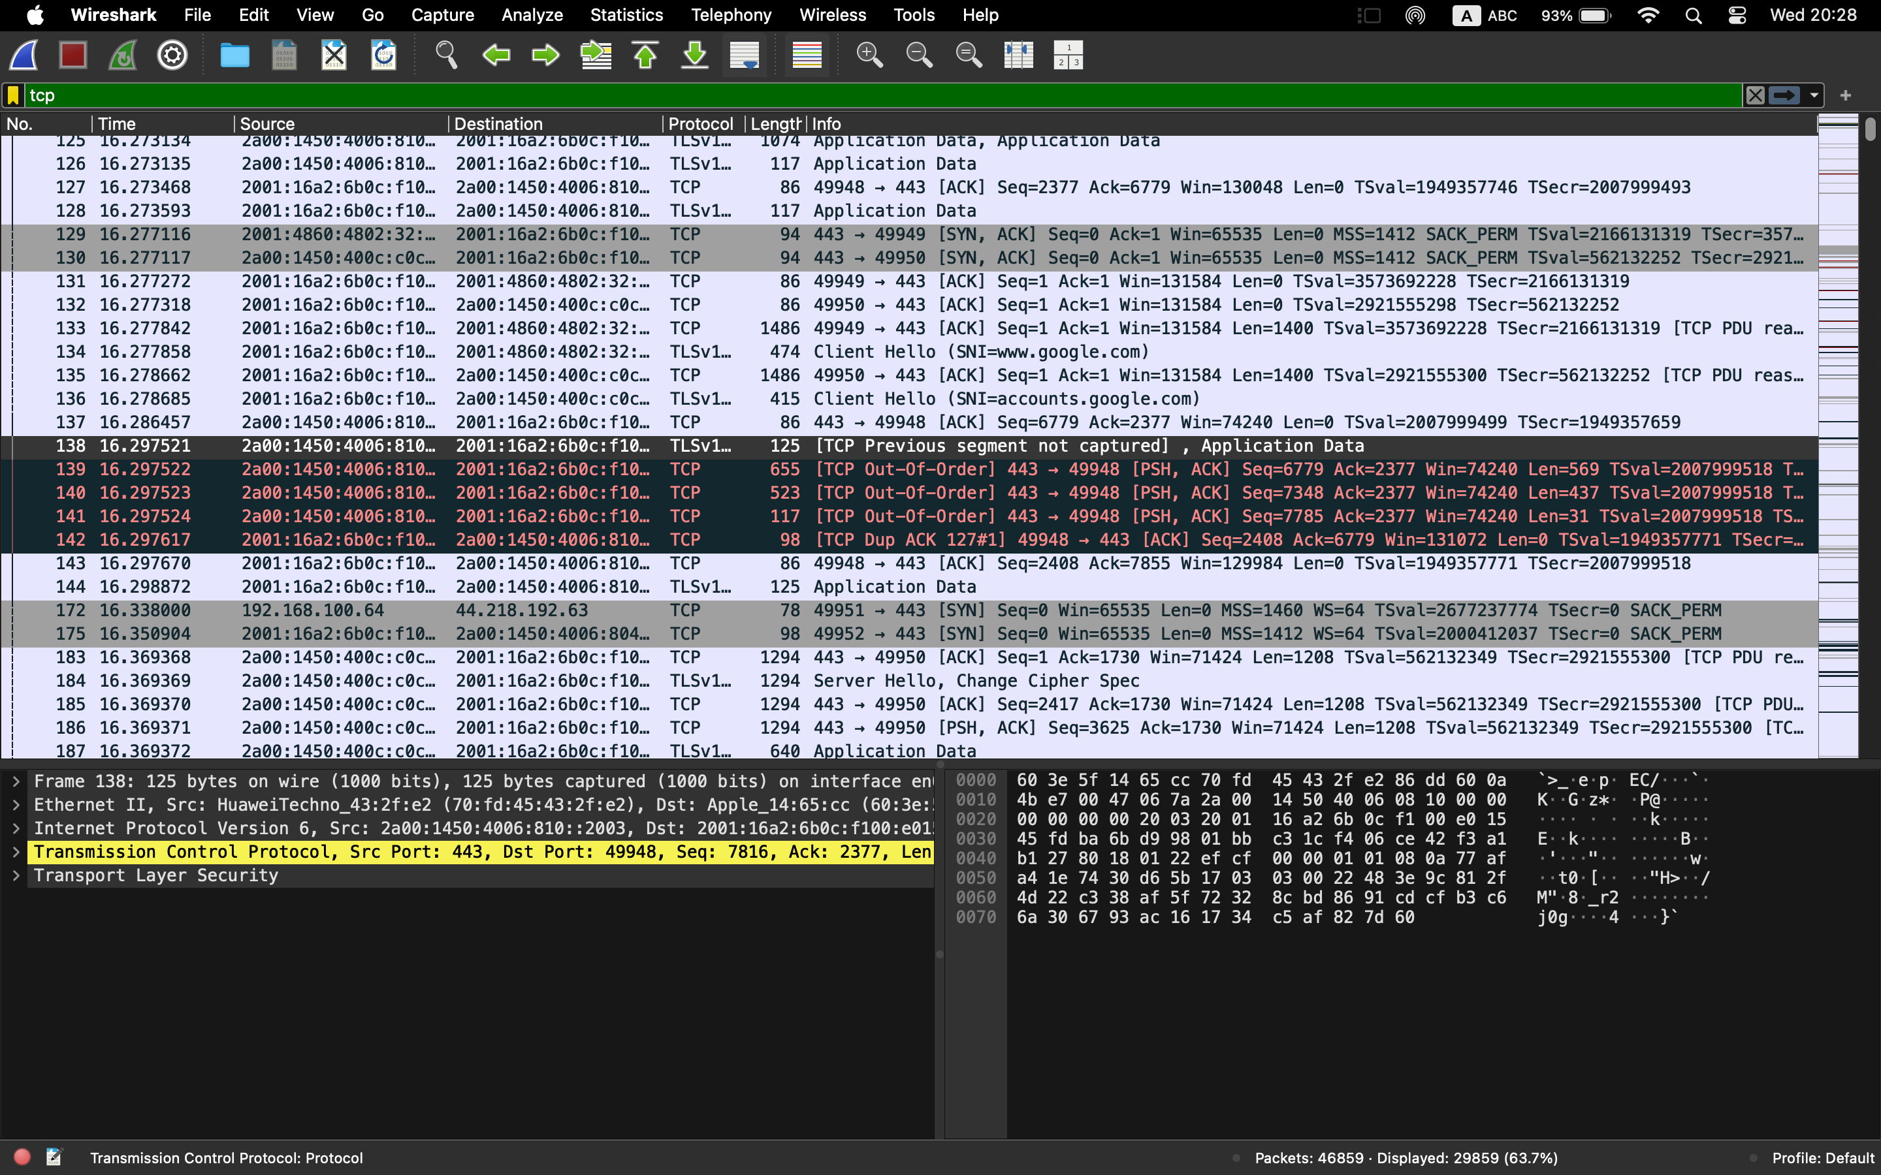

**Step 4:** Look at the TCP termination process (FIN, ACK packets).

**Part 3: Capturing and Analyzing UDP Traffic**

**Task 1: Generate UDP traffic and capture packets**

**Step 1:** Open a network application that uses UDP (e.g., streaming video, VoIP software, or custom script).

**Step 2:** Start the application to generate UDP traffic.

**Step 3:** Start capturing packets in Wireshark while the UDP application is running.

**Step 4:** After sufficient traffic is generated, stop capturing packets.

**Task 2: Filter and analysis UDP Packets**

**Step 1:** In the filter bar, type UDP and press Enter.

**Step 2:** This filters out only the UDP packets from the capture.

**Step 3:** Select any UDP packet to view its details.

**Step 4:** Observe the source and destination ports, length, and data.

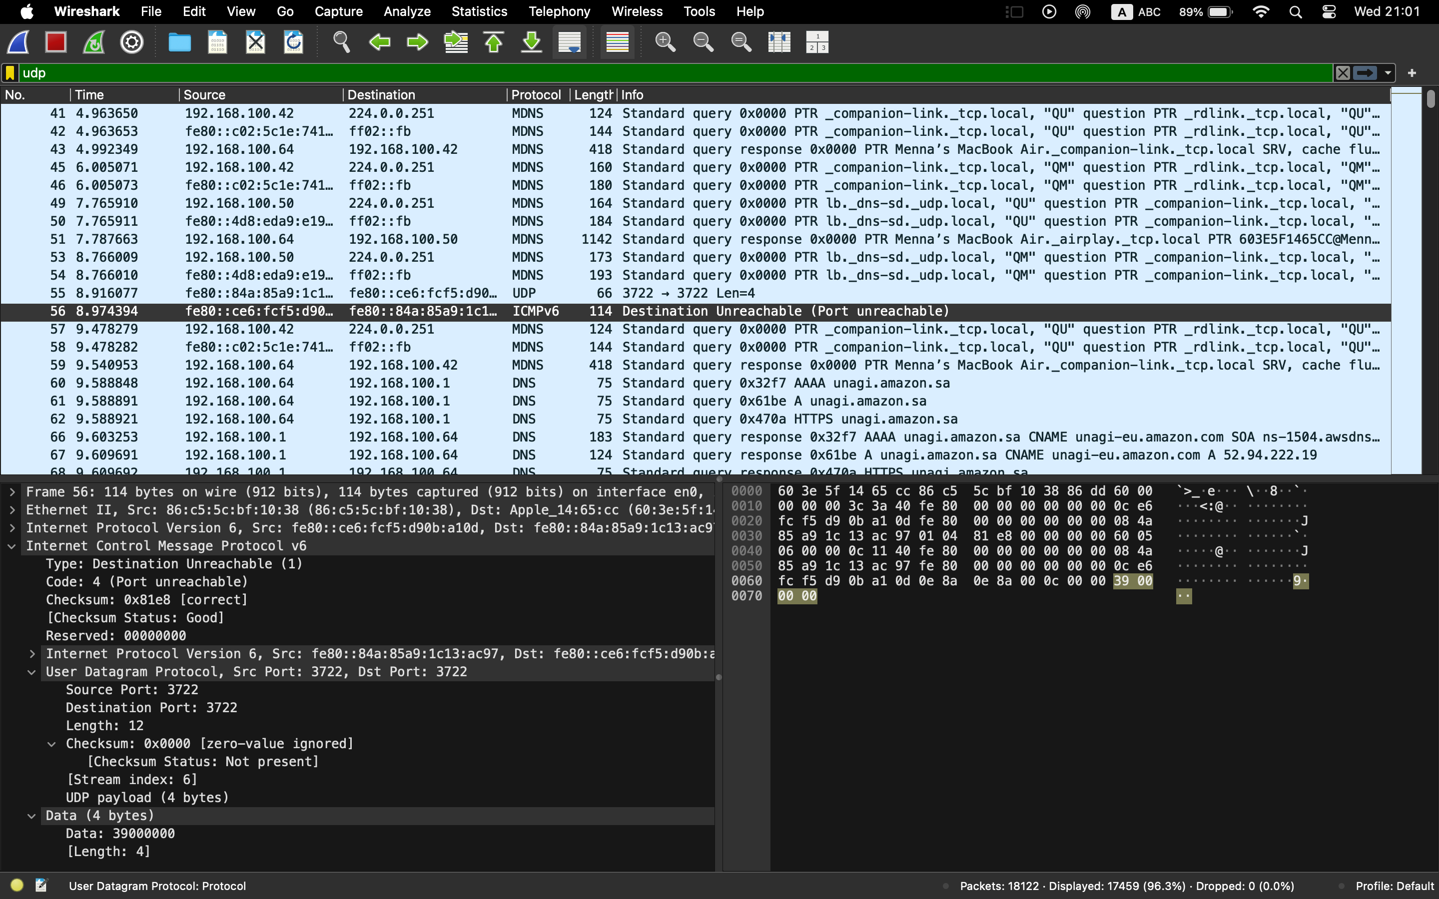

**Step 5:** Compare the simplicity of UDP headers with TCP headers.

**Part 4: Comparing TCP and UDP by filling in the following tables. Save your work (e.g., in an MS Word document), and upload it to your online git repo.**

**Task 1: Fill in the following table and provide reasons.**

|  | **TCP or UDP** | **Reasons** |
| --- | --- | --- |
| Reliability and Connection Establishment | TCP | **TCP** is a connection-oriented protocol that ensures reliability through the **Three-Way Handshake** process, which guarantees the establishment of a stable connection before data transmission. |
| Data Integrity and Ordering | UDP |  |

**Task 2: Identify the use Cases and Performance of TCP and UDP.**

|  | **TC** | **UDP** |
| --- | --- | --- |
| Use cases | - Web browsing  - File transfer (FTP)  - Email (SMTP)  - Remote access (SSH) | - Streaming media (e.g., video, audio)  - Online gaming  - DNS lookups  - VoIP (Voice over IP) |
| Performance | - Reliable, ensures ordered delivery  - Connection-oriented (slower)  - Handles congestion control | - Faster than TCP, no overhead from connection establishment  - Lightweight, connectionless  - No congestion control or error recovery |